**Analyzing YouTube Data**

Devin Smith, Tyr Smith, Ethan Snyder

**Business problems:**

Our team set out to analyze data from the “Tyr Rex” YouTube channel to answer two critical business questions. First, we aimed to determine the optimal day of the week for posting content to maximize user engagement. By breaking down the week into seven categories (Monday to Sunday) and quantifying engagement through metrics like shares, likes, views, and subscribers gained, we identified when the audience is most active and responsive. This analysis will allow the channel owner to tailor their posting schedule for better results. Second, we sought to understand which video category performs best. The videos were divided into six categories: Commentary, Gym Crush, Posing, Lifting, Informational, and Skit. Using the same metrics—views, subscribers gained, likes, and shares—we were able to identify which types of videos resonate most with viewers. Our findings will help prioritize the content that is most engaging, improving both the quality and relevance of the channel’s videos. Ultimately, we believe our data analysis answers these two strategic questions and provides actionable insights to help the channel better understand and grow its audience.

**Business context:**

To give context to our business analysis process, we first defined the problem that the “Tyr Rex” channel faces: maintaining consistent growth and engagement. Additionally, the channel must target content to its viewers more effectively to address these challenges. Developing a model was crucial to determining how we should collect data and what variables to prioritize. For the model, our objective function was video engagement, defined as views, likes, shares, and subscribers gained. The decision variables were the video category and the day of the week. Finally, we acquired the input data, which YouTube makes accessible through its Studio app. The data includes a variety of metrics that are easy to download as a CSV file, providing real-time insights to help optimize the channel.

**Data Analysis and Collection:**

To collect data, we used YouTube Studio, which allows direct data downloads. After logging into the YouTube account, we navigated to YouTube Studio, accessed advanced analytics mode, and added metrics such as likes, subscribers gained, shares, and total views to our dataset. Once set, we downloaded the data as a Google Sheet or CSV file. Afterward, we categorized the videos by type—whether commentary, gym crush, lifting, posing, skit, or informational—and matched the upload date to the corresponding day of the week. This preparation was essential for our analysis of video engagement trends by content type and posting day.

**Gurobi Optimization:**

For optimization, our team used Gurobi to determine the ideal time allocation for content creation on the “Tyr Rex” channel. Recognizing the complexity of balancing various video categories—such as commentary, posing, lifting, gym crush, skit, and informational videos—we built a linear optimization model to allocate time efficiently. We found that it takes one hour to film commentary videos, two hours for gym crush videos, one and a half hours for informational and lifting videos, one hour for posing videos, and two and a half hours for skit videos. Constraints included a total cap of 44 hours of filming per week, with at least 10 hours spent on lifting or posing videos, and another 10 hours on skit or commentary videos. Additionally, the channel must produce at least one skit video per week, and it cannot spend more than 15 hours on commentary or posing videos, nor more than 10 hours on informational or commentary videos. After implementing these variables and constraints, Gurobi produced an optimal schedule recommending the creation of 7.5 commentary videos, 5 gym crush videos, 6 informational videos, 5 lifting videos, 7.5 posing videos, and 1 skit video per week. This balanced content strategy ensures that the “Tyr Rex” channel consistently delivers a diverse range of engaging content while maximizing efficiency in content creation.

**Recommendations:**

Based on our findings, we developed several recommendations. First, we suggest maximizing posts within the most popular category—Gym Crush. Engagement is significantly higher for videos centered on this theme, and adding “Gym Crush” to the title further boosts performance. Second, the channel should post videos during the optimal days of the week, which we identified as Wednesday, Thursday, and Friday. Posting during these days is most likely to maximize overall engagement. Lastly, we recommend the channel establish a structured posting schedule. For instance, posting a Gym Crush video on Wednesday, followed by a different video type on Thursday, and another Gym Crush video on Friday can help maintain high engagement levels throughout the week and drive viewer interest going into the weekend.

PYTHON CODE SCREENSHOTS: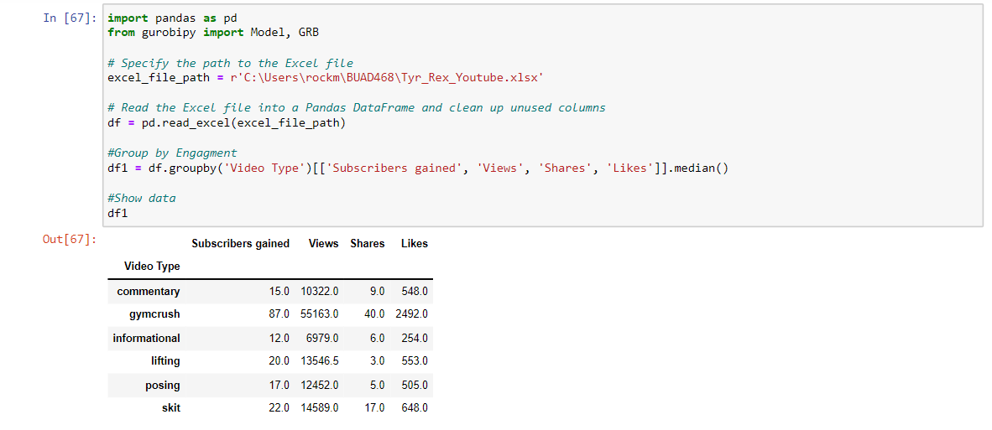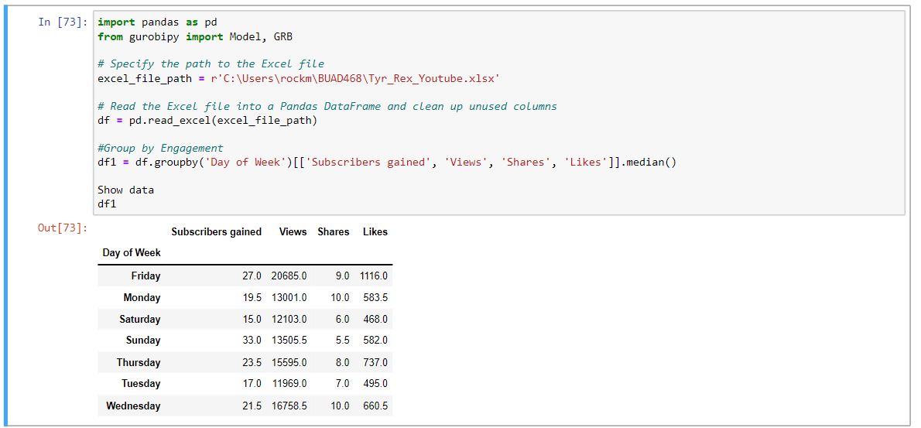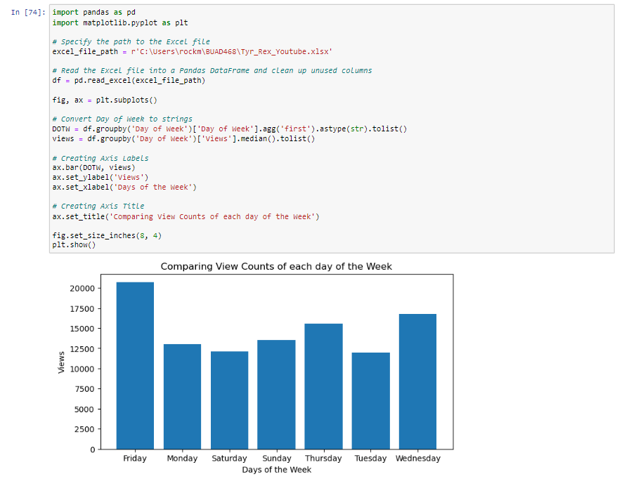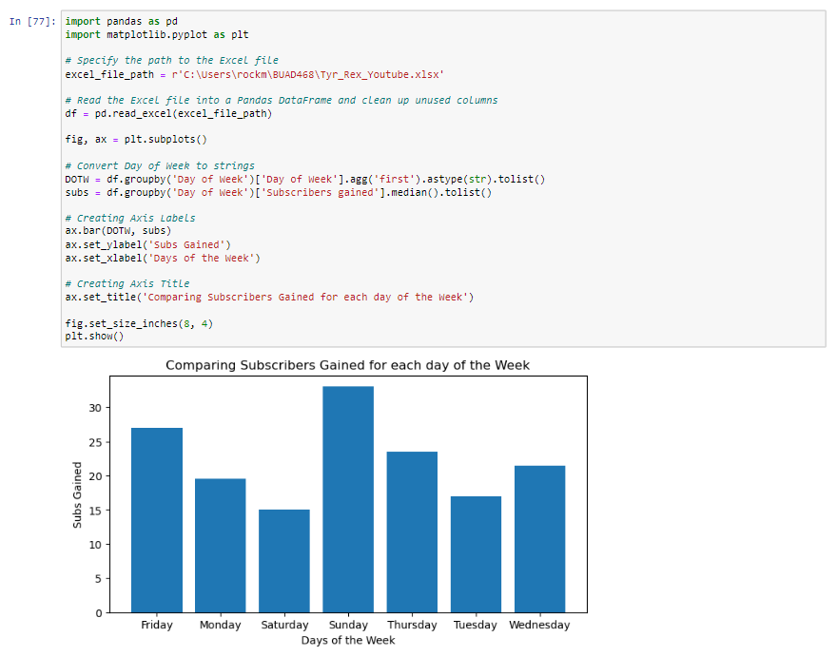

**Gurobi Code**

